The Huffman Coding Compression Algorithm
- Introduction
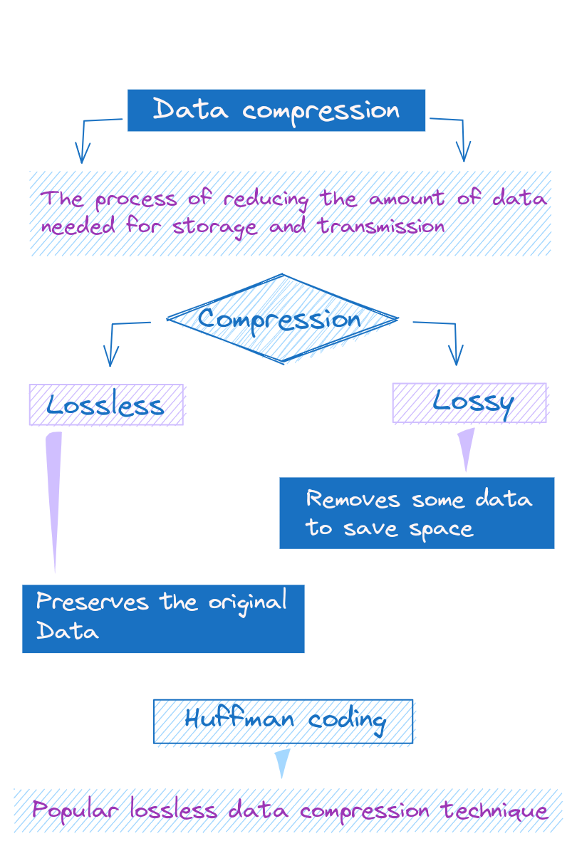

Overview of Data Compression and Its Benefits
Data compression is like packing your suitcase; it's all about fitting a large amount of data into a smaller space. This can save storage space and reduce transmission time when sending files over the internet.

Lossless vs. Lossy Compression
There are two types of compression:
- Lossless: Preserves the exact original data (like ZIP files).
- Lossy: Removes some data to save space, leading to a reduction in quality (like JPEG images).

Huffman Coding: A Lossless Compression Technique
Huffman coding is a popular lossless data compression algorithm. It’s like writing shorthand for your computer, where more frequent characters get shorter representations.

How Huffman Coding Works
The goal of Huffman coding is to create a set of variable-length codes for characters, with shorter codes for more frequent characters. This allows us to represent data more efficiently and compress the overall size.

Variable-Length Codes
Huffman coding assigns variable-length codes to input characters based on the frequency of those characters. More common characters that appear more often are assigned shorter bit sequences, while less common characters get longer codes.
For example, given the string "hello world", we would construct a frequency table:
SNIPPET
h - 1
e - 1
l - 3
o - 2
w - 1
r - 1
d - 1
The character 'l' appears most often, so it would get the shortest code. 'd' appears least often, so it would get the longest code. This encoding allows us to represent common characters very concisely.

Prefix-Free Codes
Huffman codes are constructed in a special way to ensure that no code is a prefix of another code. This prefix-free property allows each bit sequence to be decoded unambiguously.
For example, we would not assign code '01' to 'h' and code '011' to 'e', because '01' is a prefix of '011'. With prefix-free codes, the decoder can follow the bits until a complete code is formed, without ambiguity about when one code ends and another begins.
The prefix-free property is critical for allowing Huffman coding to be lossless and reversible. Given the encoded bit stream, we can unambiguously derive the original data by decoding each complete bit sequence into its matching character.
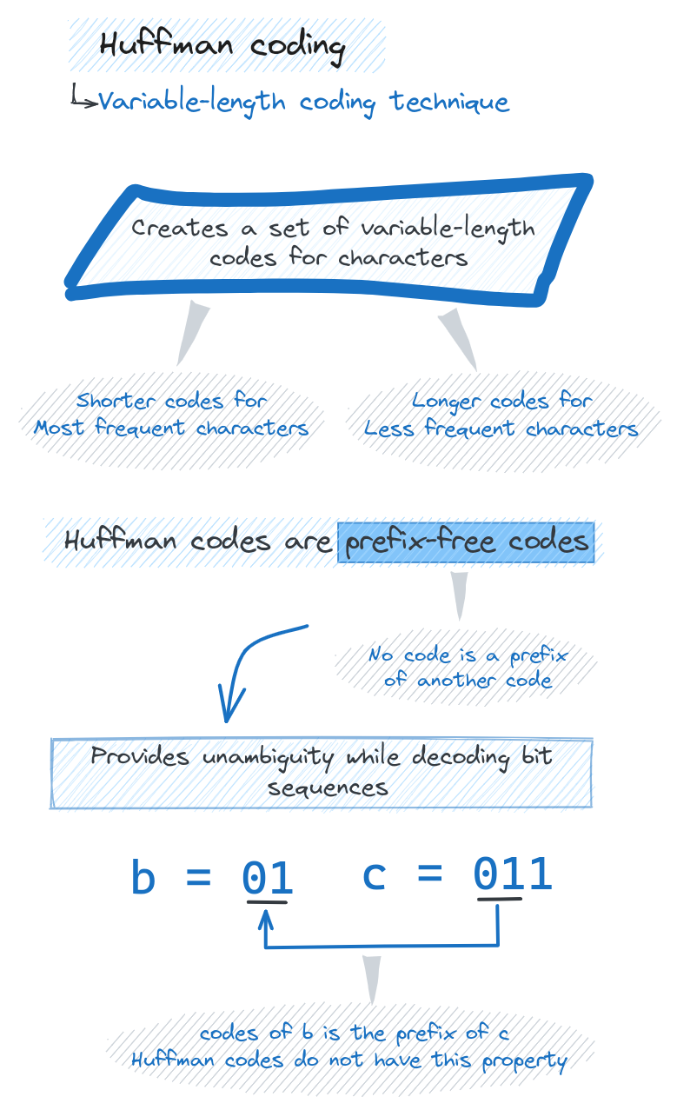

Building the Huffman Tree
Huffman coding starts by building a binary tree that represents the optimal prefix-free codes based on character frequencies.
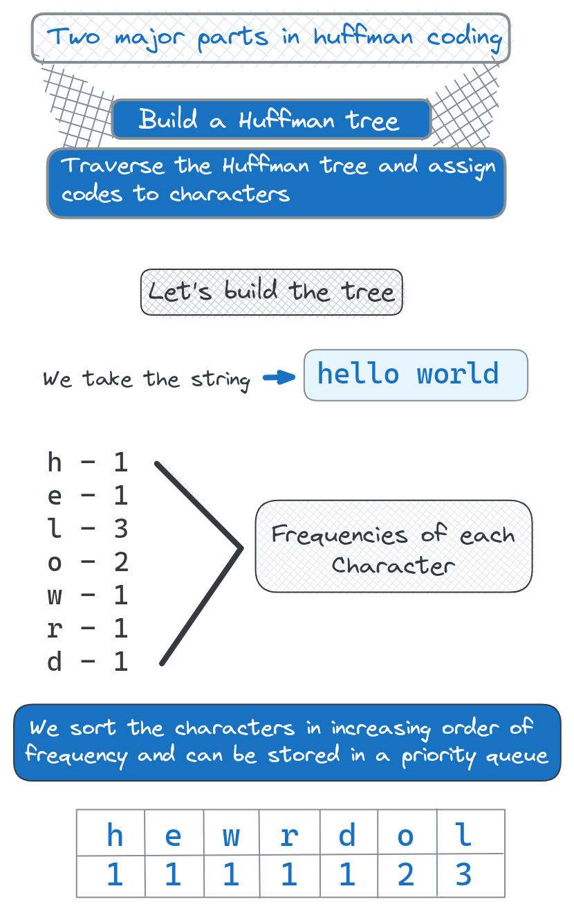
- Start with List of Characters and Frequencies
First, we need to know the frequency of each character in the input text. This is tabulated into a list of characters along with their occurrence counts.
For example, given the string "hello world", we would have:
SNIPPET
h: 1
e: 1
l: 3
o: 2
w: 1
r: 1
d: 1

Create Leaf Nodes for Each Character
We represent each character as a leaf node in the tree, containing the character and its frequency count.
These leaf nodes form the bottom layer of the tree.
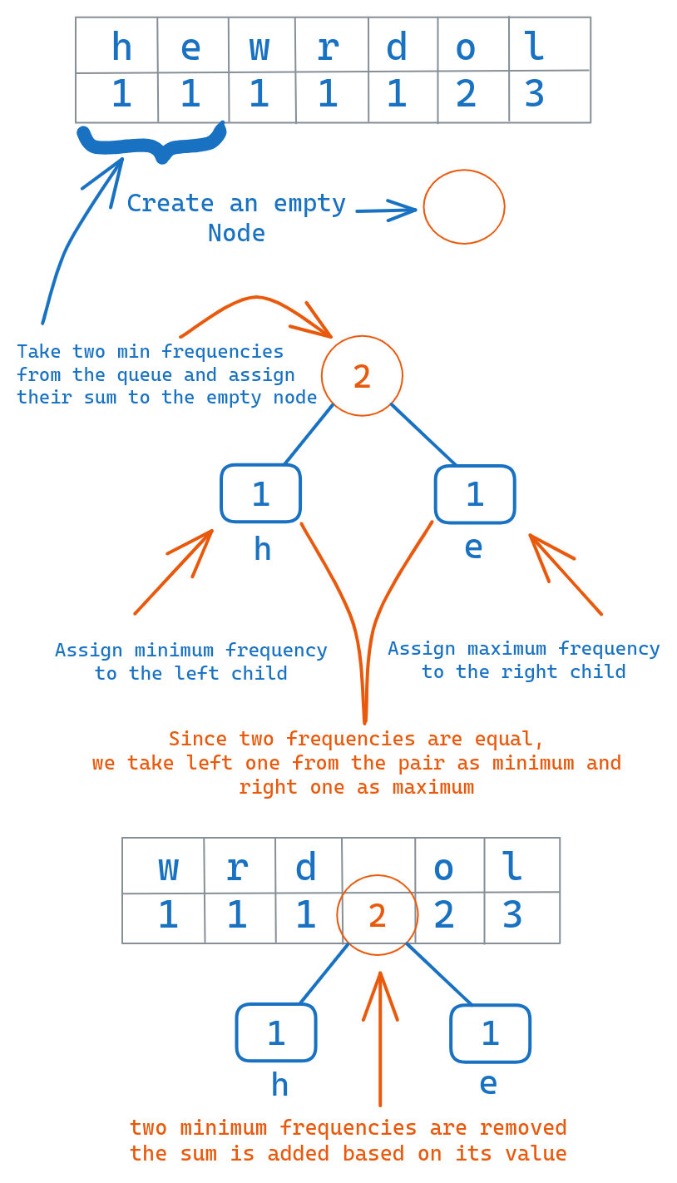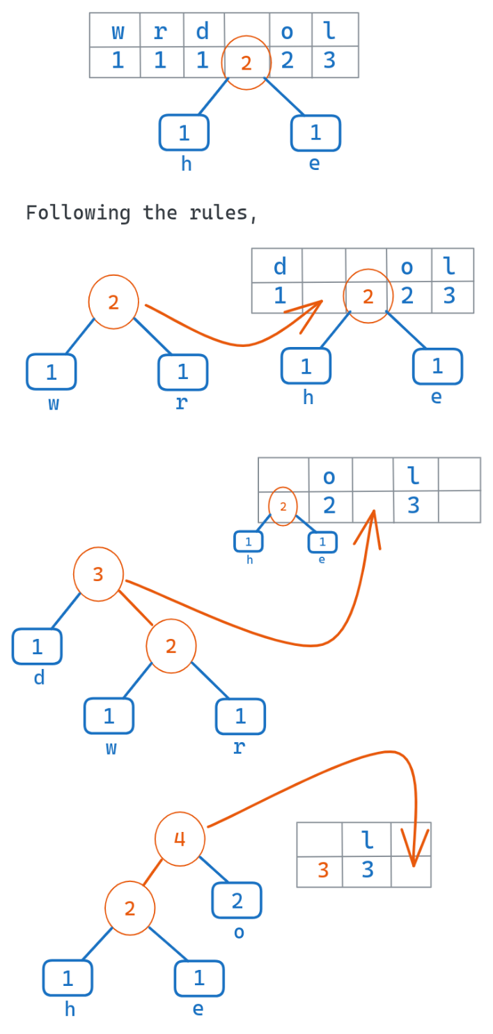

Sort Characters by Frequency
We put the leaf nodes into a priority queue or min-heap, sorted based on the frequencies. The less frequent characters will be at the top, most frequent at the bottom.
This queue structures the nodes in the order that they will be combined.

Iteratively Merge the Two Least Frequent Nodes into a Parent Node
Following the queue order, we repeatedly dequeue the two leaf nodes with the minimum frequencies.
We merge these two nodes into a parent node that has the two nodes as children, and a frequency equal to the sum of the child frequencies.
We enqueue this new parent node back into the priority queue.

Repeat until Only Root Node Remains
We repeat this process of merging the two minimum nodes into a parent, until only one node remains in the queue.
This final node is the root of the entire Huffman tree.
